A SMART WIRELESS SYSTEM TO AUTOMATE PRODUCTION OF CROPS AND STOP INTRUSION USING DEEP LEARNING

Alternative Title:

Machine Learning Based Smart Roadside Animal Detection System to Reduce Animal-Vehicle Collision

Aim:

Aim of the project is to reduce animal-vehicle collision on roadsides using machine learning and raspberry pi

Abstract:

Animal-Vehicle collisions are a significant public health concern in various countries. The annual economic cost exceeds over a billion from injuries property damage. From 2011-2012 till July 2019, as many as 11,915 stray animals including dog, cats, cattle and goat were injured in road accidents in different part of the city, data prepared by Nagpur Municipal corporation veterinary department has revealed. According to State of India's Environment 2019 e-book, 161 wild animals died in road, rail accidents in 2018.According to the accident research study conducted by JPResearch India Pvt. Ltd. for the Ahmedabad-Gandhinagarregion (cities of India), for the duration February 2014 to January 2015, total 206 road traffic accidents were recorded and these were influenced by three main factors i.e. human, vehicle, infrastructure or a combination of them. From the record 6% (12 accidents) were due to animals on the road.

Various methods and approaches were implemented like fencing, placing sign boards, installing sensor alert systems and to reduce these accidents. In this project, a simple and a low-cost approach for automatic animal detection on highways for preventing animal-vehicle collision using computer vision techniques are proposed. The proposed system is trained on more than 2200 images consisting of positive and negatives images and tested on various video clips of animals on highways. Here, we are using a small portable computer raspberry pi and a camera placed along roadsides with particular distance. When animal detected on road current node send the alert signal to previous and next node.

Existing system:

Existing system used in crop filed to detect limited number of wild animals and using tensorflow model to detect the animals. Usage of tensorflow model leads to lag in detection of animals. It needs high frame rate cameras to compensate the delay in detection process.

Proposed system:

Proposed system used to detect animals on roadside to avoid animal-vehicle collision, we have trained more than thirty various wildlife animals and each one consists more than 2000 positive and negative images. After training Tensorflow model, it is converted into tflite model to increase the detection speed at lower frame rate.

Block Diagram:
USB port
USB camera

Wifi
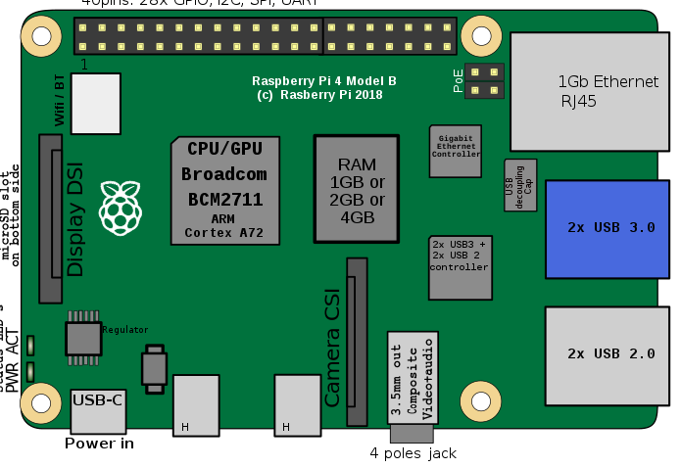
Raspberry pi 4

Alert Signal
Cloud database
GPIO Pins

Block Diagram Description:

In this block diagram, raspberry pi act as main controller which is responsible for controlling all other components. Camera used to capture live video and send to raspberry pi, here every frame fed to CNN model. If any wild animal detected in the frame, raspberry pi send the signal to GPIO pins for activating red signal. Also it sends the alert signal to adjacent nodes and cloud database. Cloud database contains node ID, location of node and animal detection status.

Hardware Requirements:

Raspberry pi 4

USB camera

Software Requirements:
- Language : Python
- Compiler : GCC Complier
- OS : Linux

